Foundations of Algebra Name ________________________

Read the direction very carefully.
Be sure you label all the necessary information.
Show all your work.

- Using three points method, graph 𝑦$=-\frac{2}{5}$x + 2
x | 0 | 5 | -5
y | 2 | 0 | 4

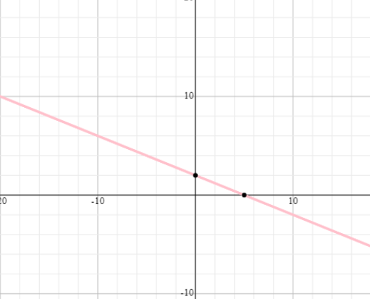

- Using the slope formula, determine the slope of a line that goes through (2, 3) and (-22, -5).

M= $\frac{y2-y1}{x2-x1}$

M= $\frac{-5-3}{-22-2}$ $\frac{-8}{-24}$ M= $\frac{1}{3}$

10/25/17
Foundations of Algebra Name ________________________

20 points

- Using the intercepts method, graph -4x + 5y = -20.
x | 0 | 5
y | -4 | 0

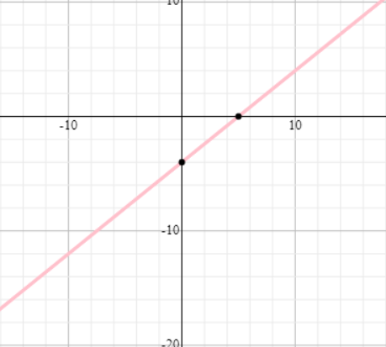

- On the graph, there is a line. What is the slope of a line using rise/run method?

y


m = ____1/2___________

Bonus: ( +2)

x

What is the equation of a line?

½= $\frac{y-2}{x-0}$ y=-1/2x +2
___________________________
10/25/17

